Mendel University of Agriculture and Forestry Brno
Faculty of Agronomy
Department of Applied and Landscape Ecology

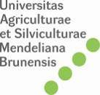

1st Moravian Conference on Rural Research
EURORURAL '08

INVESTIGATING
EUROPEAN COUNTRYSIDE

Excursion Guide
August 28, 2008

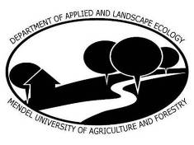

Brno, Czech Republic
Mendel University of Agriculture and Forestry Brno
August 25 - 29, 2008

URL: http://www.uake.cz/novinky.html

- The city of Brno
- Suburban zone Brno – South and Modřice
- Road Brno - Vienna
- Nové Mlýny waterwork
- Pavlovské vrchy hills
- Mikulov town
- Valtice town
- Lednice village
- Lednice Valtice Area
- South Moravian countryside
- Bořetice village

The city of Brno

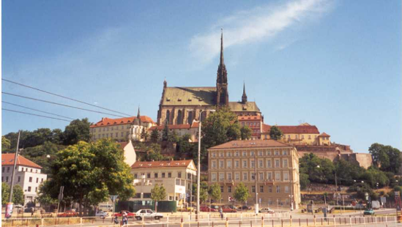

Population: 400 034 (Ministry of Interior, 1.1.2008)
Average age: 41.5 years; natural increase 0.3 ‰, migration increase 4.3 ‰ (2007)
Geographical position: 49°21´N, 16°34´E, 190 – 425 m a.s.l.
Area: 23 019 ha (of it 2 090 ha built-up, 7 994 ha agricultural, 6 370 ha forest area)
History: 1091 first mentioned, 1243 royal privilege, 1641 capitol of Moravia, 1645 successful defence against Sweden, 1742 against Prussia, 1805 Austerlitz battle, 1839 first railway connection, 1865 formulation of the genetic theory by J.G.Mendel
Administration: seat of the Constitutional Court, Supreme Court of the Czech Republic, Supreme Administration Court, Czech Ombudsman Office, Czech Office for the Protection of Competition, Regional office of South-Moravian Region and other regional offices, Magistrate of the City, offices at the district level for Brno-city and Brno-surroundings, the Brno Metropolitan Court (the largest in Czechia), 29 local offices, general consulates of Russia, Slovakia and Ukraine, honorary consulates of Angola, Austria, Poland, Lithuania
Education: 6 state and public universities with 29 faculties, 73 thousand students and 4,300 people of academic staff, 14 colleges, 66 secondary schools
Science and technology: 13 institutes of the Czech Academy of Sciences or their branches, Czech Technological Park
Investments: new campus of Masaryk University – 180 millions EUR, new cardiologic centre of St. Ann Hospital Brno and Mayo Clinic (Rochester, Minnesota) – 65 millions EUR etc., Industrial zone Černovická terasa, Brno South Centre, Reconstruction of the Railway junction, Motorway R43 etc.
Libraries: Moravian Land Library (4 million issues), Metropolitan Library (800 thousand issues), university libraries (2.8 millions of issues)
Culture: 14 theatres, 38 galleries, 16 museums, zoo, 60 churches
Health care: 12 hospitals, 7.8 physicians/1 000 inhabitants
Transport: Metropolitan Transport Enterprise in operation since 1869: 13 tramway lines, 11 trolleybus lines, 49 bus lines, 1 shipping line, 340 millions of transported persons (2006); South Moravian regional integrated transport system; intersection of motorways of D1, D2 and R52, Tuřany international airport with regular lines to London, Moscow, Girona and Prague (415 thousands of passengers, 2007)
Trade Fair Grounds in operation since 1928; in 2006: 42 events in 27 blocks, 10,800 exhibitors from 65 countries, 999 thousand visitors
Local sights: Tugendhat Villa (UNESCO world heritage), medieval architecture (Špilberk castle, town halls, churches), modern architecture (art nouveau, constructivism)
Festivals: International Music Festival, Festival Brno – the City in the middle of Europe (including Ignis Brunensis)
Masaryk Racing Circuit tradition since 1930, new circuit since 1987, 5.4 km, 14 curves, world championship of motorcycles since 1965, many other events and trainings of drivers
Surroundings: Austerlitz battle field, viniferous South Moravia, terrains of Bohemian-Moravian Highland, Moravian karst

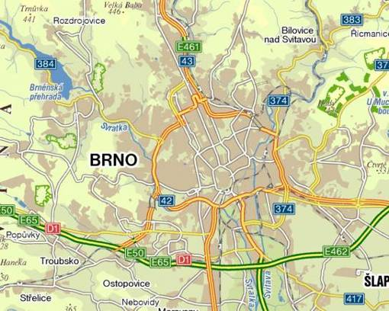
The suburban zone Brno-South and Modřice

Optimum conditions: free relatively flat areas (because the soil of the best quality was protected in the era of socialism), vicinity of main highways D1, D2, R52, very comfortable accessibility from Brno
Case study Modřice
Population: 4 509
Area: 1 005 ha, of it 699 ha agricultural: orchard, gardens, vineyards, no forests
Originally agricultural seat (cabbage, onion for Brno), church ownership, German population (80 % of inhabitants transferred after the WWII)
Railway connection: since 1839, followed with industrialization
Primary sector 2,5 %, secondary sector 33,5 % of economically active people
University education: only 9 % of inhabitants in the age 15+

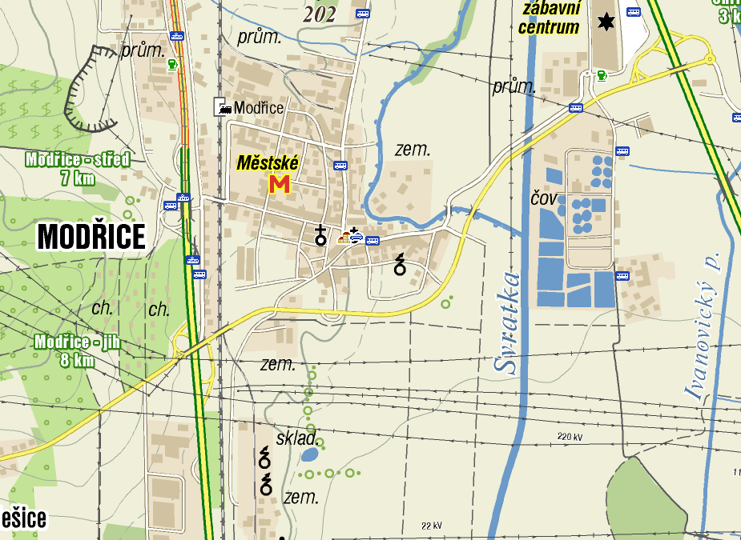

Residential suburbanization:
The direction south of Brno is not very popular due to the flat terrain, lack of forests and loading with transport
Development: 2 423 inhabitants (1950), 4 115 inhabitants (1980 due to industrialization and urbanization), 3 984 inhabitants 1991, 4 509 inhabitants (2008)
Inhabited houses: 570, inhabited flats: 1 294 (2001)
Ownership structure: 39,6 % flats in own house, 23,5 % own flats in a block, 20,9 % cooperative flats, 10,3 % tenant flats
Quality of dwellings: 55,9 % flats in blocks, 43,6 % in houses; 81 m² per a flat, 19,5 m² per capita, 0,94 persons per a room; 98,7 % flats connected with the public water system, 94,2 % with public gas system, 86,8 % with public sewage system; 98 % flats equipped with bathroom, 97 % with WC, 70 % with central heating system
Elder dwelling structures:

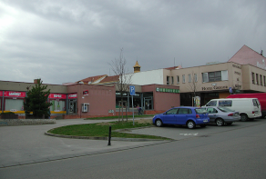 | 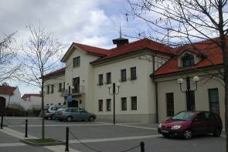
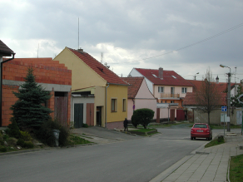 | 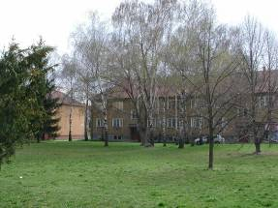
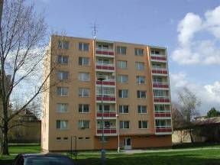 | 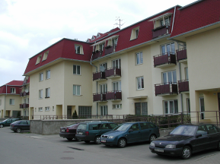

Suburbanized structures:

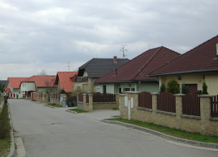 | 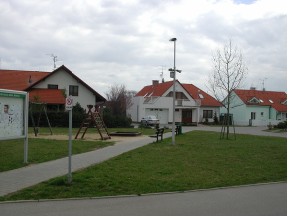
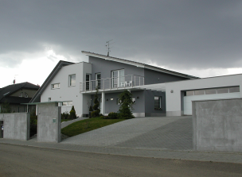 | 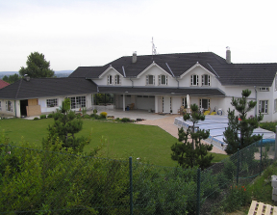

Commercial suburbanization: Shopping and Entertainment Centre OLYMPIA (1999)
The 2nd largest in Czechia; 140 shops, 84,000 sqm of shopping area
Palace Cinemas (10 cinemas, 2,287 seats)
Parking place for 3,200 cars
Turn-over 110 million EUR per year

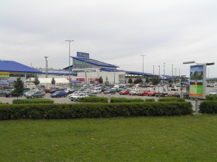 | 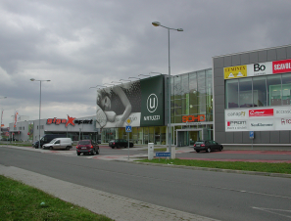

Industrial suburbanization:
Original industry: KOVOLIT (metallurgy – still produces), sugar refinery, brickworks, canning factory FRUTA: out of operation. In their areas storages and SMEs can be found.
CENTRAL TRADE PARK MODŘICE – Dutch ownership
400,000 sqm, of it 45 = built-up
22 firms in industry and logistics, 2,000 jobs

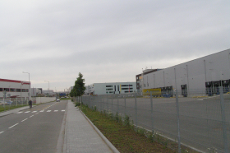 | 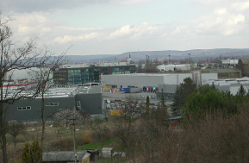

Modřice are connected to the network of the Metropolitan Transport Enterprise of Brno and together with it to the Integrated Transport System of the South Moravian Region
Connection with Brno by train (time of a ride 7 minutes, interval 30 minutes), by tramway (interval 5 – 10 minutes), 22 bus lines, a night bus line (interval 30-60 minutes), special bus lines to Olympia and Central Trade Park free of charge
Modřice have 6,281 occupied job opportunities (3times more than the number of economic active people)
Totally 2,614 persons commute to Modřice for work, from it 1,317 from Brno
For 936 of commuters the time of commuting is less than 30 minutes
Brno is for Modřice the main commuting centre and vice versa
Modřice are active in the mutual exchange including commuters to schools in Brno
Unemployment rate (IV/2008): Brno 5.7 %, Modřice 2.5 % (Czechia 5.2 %)
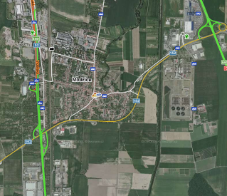
Road R52 Brno - Znojmo and Brno - Vienna

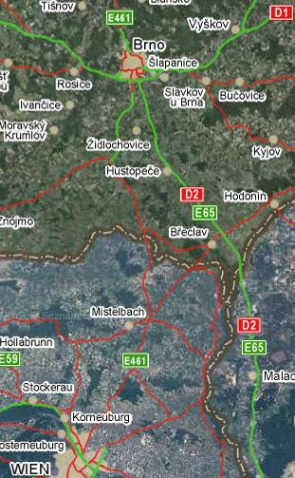
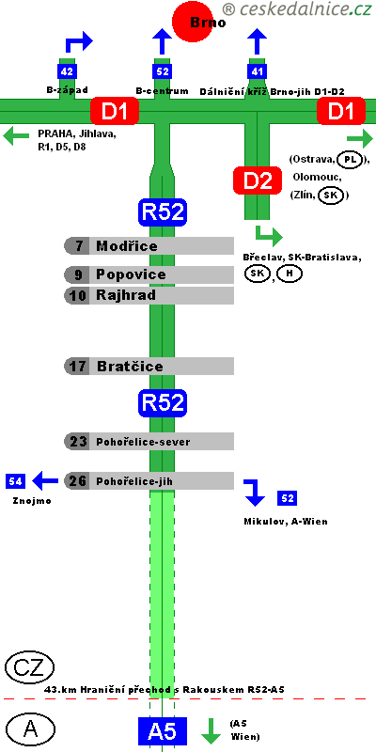

Connection of the motorway-type between Brno and Vienna is very urgent. It is used not only by Czech and Austrian motorists but also by cars from Poland and Baltic states in one side and by Slovenes and Italians from the other one.
The road started to be built during the WWII as a part of the highway Vienna – Wrocław.
At the present time, the part Brno – Pohořelice has parameters of the high-speed road. Also some very short parts in Austria were opened as parts of the A5 Nordautobahn Wien – Drasenhofen. The work wold be finished in 2009 on the Austrian side, in 2014 in the Czech side.
Recently, the Greens have started to fight against the completion of the whole road. They prefer to connect Břeclav (situated on the highway D2 Brno – Bratislava, which has only a very limited traffic after the split of Czechoslovakia) with Vienna.
Similar situation was observed in the history. In 1830s, Mikulov was one of the most important towns in Moravia. The town refused the railway because of possible competition with local carters. Finally, the railway was built via Břeclav. As a consequence, Mikulov has remained the small town, Břeclav grew up in the district centre. Will the situation repeat?

Nové Mlýny water work

Originally the widest alluvial plain in central Europe till 1970s
Aim of the water work: flood protection, irrigation. Period of construction: 1975 - 1988
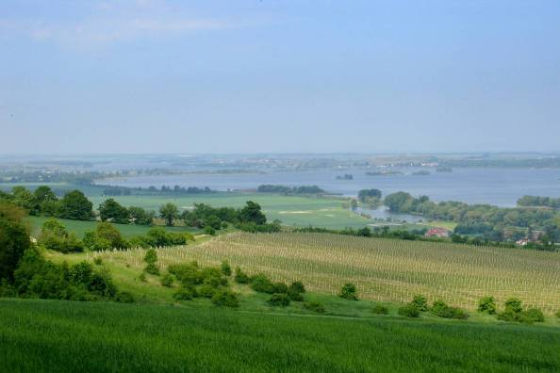

System of three water reservoirs:
The upper one (Mušov reservoir) serves for irrigations and tourism; camp Pasohlávky is situated on the left shore
The middle one (Věstonice reservoir) is a protected area with artificial islands for netting of birds; romanesque-gothic church of St. Linhart – the only reminder of the flooded village Mušov is situated on one of the islands
The lower one (Nové Mlýny reservoir) serves for irrigation, tourism and power production
The surroundings are very suitable for cyclo-tourism

The area under the Pavlovské vrchy hills has been colonized since paleolithic ages. Venus of Dolní Věstonice (nude female figure dated 29,000 – 25,000 BCE, discovered in 1925) is the oldest known ceramic in the world.
The campus of the 10th Roman legion from the period of the emperor Marcus Aurelius (171 – 180) including baths was discovered in the Mušov area.
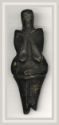

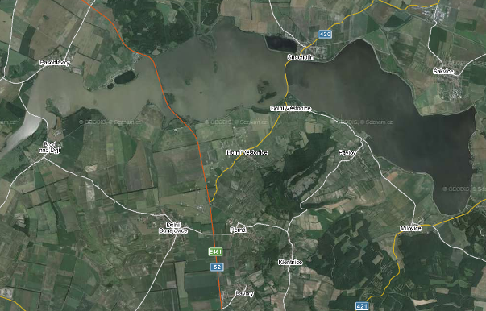

The water work is one of the most controversial human interventions to the landscape in Moravia. The very valuable natural area was definitively lost. On the other side, the originally assumed aims of the waterwork (irrigation, flood protection, recreation) were fulfilled only partly. But the Pavlovské vrchy Hills mirrored in the Nové Mlýny water reservoir manifest aesthetically very expressive landmark.

The Pavlovské vrchy Hills (Pálava)

A limestone formation 20 km long elevated within the Alpine folding – a part of the Mikulovská vrchovina Highland. The highest point is 549 m above the sea level.
Protected Landscape Area Pálava was declared in 1976. It contains Pavlovské vrchy Hills and Milovický les Forest with total area of 86 sqkm.
Biotopes of species-rich rock and meadow steppes, forest steppes, thermophilic oak-woods, debris forests are protected there. Two enclosures for wildlife breeding are situated in the area.
In 1986, the protected landscape area was declared as a UNESCO Biosphere Reservation.
The Special Protection Area on the convention of wild birds under the EU directive within NATURA 2000 occupies the whole protected area.
The Pavlovské vrchy Hills consist of Massif Děvín with a transceiver and ruins of the gothic castle Děvičky (built before 1222, abandoned at the beginning of the 19th century), Soutěska (Gorge) dividing Děvín and Kotel, Massif Kotel with Obora and Pálava tops, Stolová hora (Mesa) with ruins of Sirotčí hrádek castle (built in 13th century, wasted in 16th century), Kočičí skála (Cat Rock) natural monument, Turold Hill above the town of Mikulov with the cave Na Turoldu (length of corridors 2 km, made accessible in 1967), Svatý Kopeček (Holy Hill) a pilgrim seat with St. Sebastian Chapel and the Calvary, Šibeničník (Gallows Hill).

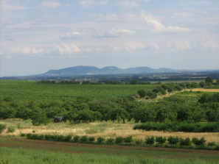 | 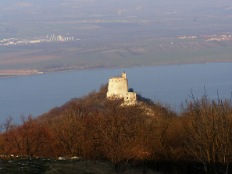
Pavlovské vrchy Hills from the north-west | Ruins of the Děvičky castle
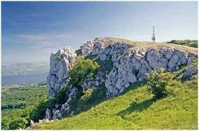 | 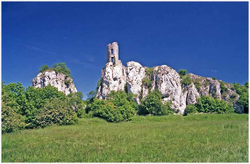
Rocks on the Děvín Hill | Ruins of the Sirotčí hrádek castle
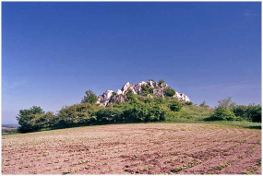 | 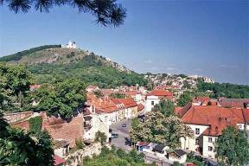
Rock Hill | The Holy Hill with St. Sebastian Chapel

Mikulov town

The town Mikulov arose in 12th century, it is a town since 1410.
Situated directly on the border with lower Austria, one of the most frequented border crossings since the communist times, is the place where the future highways from Vienna and Brno should meet.
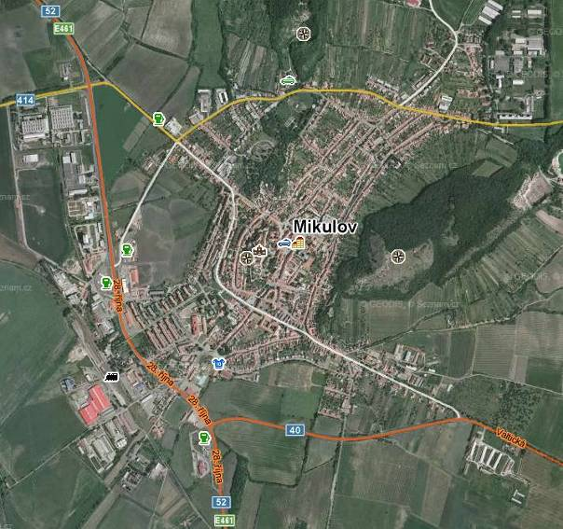

Population: 7 400, area: 45 sqkm, 242 m above sea level
Centre of administrative services for 17 villages in its surroundings.

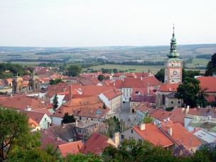 | 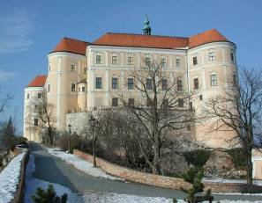
The historical core of the town | Mikulov chateuau

Royal castle protecting the commercial pathway from the North to the South was found by Přemysl Otakar I in 1218. The town which arose under the castle was gifted to the Liechtenstein family in 1249, who sold the town to the Dietrichstein family in 1575. The realities were owned by Dietrichsteins till 1945.
The castle was built in the late romanesque style. In the middle of 16th century, the fortress was reconstructed with respect to the Ottoman danger and development of weapon systems. In the turn of 17th and 18th century, the castle was rebuilt in a renaissance chateau. The park with exotic trees was found. The chateau was burned out by withdrawing German army at the end of the WWII. That time it lost all the historical inner equipment. Some buildings were renewed and the museum was established in 1959. The museum is oriented in the wine tradition and history.
Mikulov was a very important place frequently visited by European landlords and the place of many negotiations. The peace of Nikolsburg between Prince Gabriel Bethlen of Transylvania and Emporor Ferdinand II of the Holy Empire of Rome was signed here in 1621 within the Thirty Year´s War. Negotiations between Napoleon and Russian and Austrian Emperors after the Austerlitz battle ran over here as well as negotiations between the Prussian Emperor Wilhelm and Habsburgs after the Battle by Hradec Králové (1866).
Mikulov became the seat of the Jewish rabbin for Moravia in the middle of 16th century and by this way also the spiritual and administrative centre of Moravian Jewish community. In the half of the 19th century, Jews performed a half of the population of Mikulov. After 1848 when the political situation improved, some Jews moved for other towns. The history of Jewish community of Mikulov was finished by the Nazi occupation.

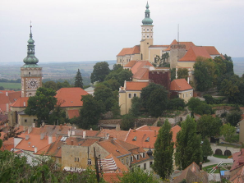 | 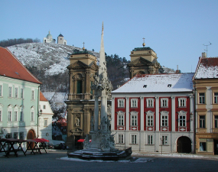
Mikulov – general view | Mikulov – the square

The town lost its importance in 1840s. It was decided that the railway connection between Vienna and Brno will be constructed via much less important (that time) town Břeclav. The traffic was inaugurated in 1939 and Břeclav started rapidly grow partly to the prejudice of Mikulov. Important industrial plants were situated in Břeclav whereas Mikulov remained a town of (that time underestimated) services. The situation was conserved also in the times of planning economy. Mikulov was industrialized later by light industries: machinery, food industry. The town is a productive base of the wine-making industry. Industrial zone grew up on the western edge of the town.
As a consequence of the WWII, the majority of German population was expelled in 1945 and 1946. The number of inhabitants had decreased from 8,000 to 5,200.
The main architectonical sights in Mikulov besides of the chateau are as follows:
The main square is dominated by former St. Ann Church which was rebuilt for a church-tomb of the Dietrichstein family after the fire in 1784. There are fountain and the monument of Holy Trinity in the square. The Knights House with sgraffito is the most interesting among houses.
The synagogue in the baroque style in the middle of 90 renaissance Jewish houses and Jewish cemetery remember the history in Jews in Mikulov.
St. Wenceslas church (15th century) is a seat of the Collegiate Chapter House. baroque St. John Baptist Church is situated within the Piarist Grammar-School, St. Sebastian church was built after the plague in 1622, St. Nicolas church, originally German evangelic was bought by the orthodox church.
The tourist industry is based on architectonic and historic heritage, wine culture, congress tourism and natural beauties in the surroundings of Mikulov.

Valtice town
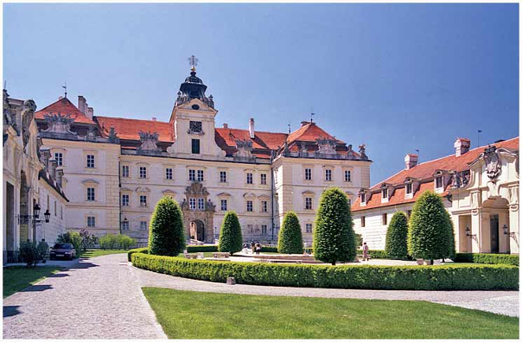

Population 3,600, area 48 sqkm, 192 m above sea level
Colonised by bishops of Passau in the 12th century (first mentioned 1192).
Ownership of the Liechtenstein family 1391 – 1945
Part of Lower Austria till 1920, afterwards connected with Czechoslovakia according to the Saint Germain agreement
The landscape of the town is dominated by the Church of the Virgin Mary Assumption. Other important buildings in the town and its surroundings are among others: baroque chateau – former seat of the Liechtenstein family (originally a gothic castle), chapels of St. Joseph and St. Hubert, convents of Franciscans and Hospitalers, manor houses Belveder and Border House, temple of Goddess Diana, Three Graces, Reistna colonnade.
Valtice is the town if wine. A thousand years tradition qualifies the present glory. Valtice is the place of wine production, wine education, wine celebrations, wine exhibitions (since 1858), wine markets – altogether about 100 events per year. The life with wine is connected with folklore.
Following important activities connected with wine are situated in Valtice: Secondary Technical Wine School (the only in Czechia, found in 1873), National Wine Centre (including Chamber of Wines), Union of Moravian Wine-Makers, Wine Academy od Valtice (association supporting wine culture) and other.
National agricultural museum is situated in Valtice.

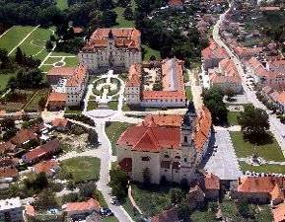 | 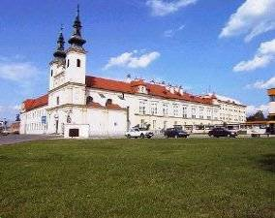
Valtice: historical core | Valtice: Virgin Mary Assumption church
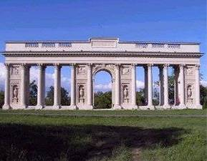 | 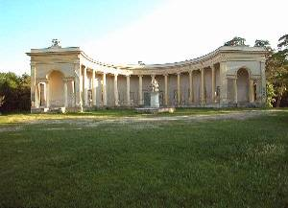
Vatlice: the Colonnade | The Temple of Three Graces

Lednice village

Population: 2,400
First mentioned 1222. Ownership of the Orphans family, early went over to the Liechtestein family; settlers from Austria came in 13th century
Original border castle was rebuilt for a renaissance chateau with garden in 16th century.
Round the year 1800, Josef Hardtmuth invented a pencil in Lednice. The production was later moved to České Budějovice
The village was preliminary Czech in the half of the 19th century. But later the Liechtesteins brought German clerks and officials. As a consequence, the German population was evacuated after the WWII.
Agricultural High School was found in Lednice in 1895. It was replaced by the horticultural section of the Faculty of Agronomy of the Agricultural University in Brno. In 1996, the section was changed for a Faculty of Horticulture, Mendel University of Agriculture and Forestry.
Spa function is a new activity in the village. Lázně Lednice Spa uses the iodine-bromine waters for treatment. Illnesses of joints, skeleton, blood vessels and traumatogenic stages are treated here.

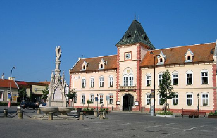 | 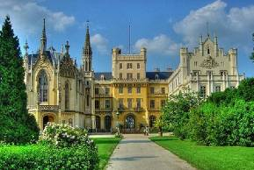
Lednice – the main square | Lednice chateau
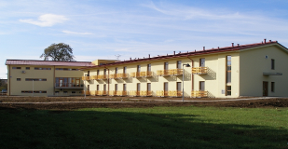 | 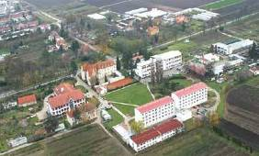
Lázně Lednice Spa | Faculty of Horticulture Lednice

There are 37 protected objects on the territory of the village

The Lednice – Valtice Area
part of the UNESCO world heritage since 1996

The largest cultural landscape area in Europe made by the Liechtenstein family
The area is the third most important tourist attraction in Czechia (after Prague and Český Krumlov) and the first in Moravia. The Lednice chateau only is visited by 280,000 visitors annually.
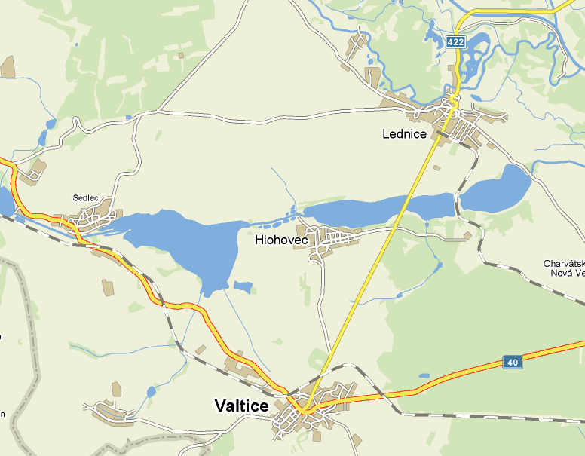

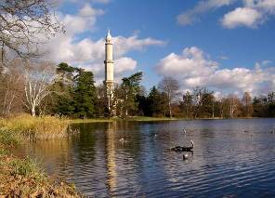 | 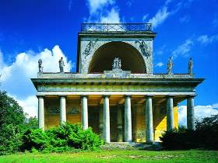
The minaret | Apollon temple

The area (200 km²) is composed of chateaus in Valtice and Lednice, man-made landscape with fishponds and sparse trees and about 20 smaller architectonical objects, as a Prayer Tower, Belvedere manor house, Janův hrad (artificial ruins of a small castle), Temple of Apollon and others.

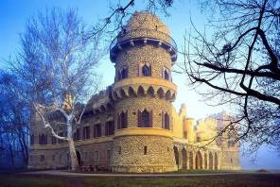 | 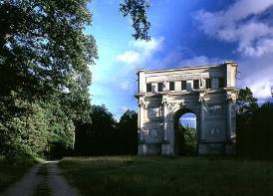
Janův hrad castle ruins | Randez-vous

Rural settlement of south Moravian lowlands

The settlement consists of a network of small towns and large villages with population 2,000 – 3,000 which are relatively distanced each from other.
Historically, the centre of Great Moravia, the cradle of Christianity in this part of Europe (Constantin and Method came to this area in 863 from Thessalonike, being invited by the Moravian prince Rastislav), was situated somewhere in this region.
Economic activities were connected mostly with primary sector – agriculture in its industrial stage, elaboration of agricultural products, services for agriculture, wine culture.
Living folklore tradition is connected with this region called Moravské Slovácko (Moravian Slovakia). The folk dance “verbuňk” is a part of the non-material UNESCO world heritage. Traditional folk songs make the tradition of the region worldwide.

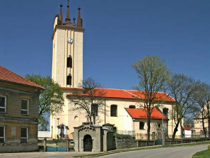 | 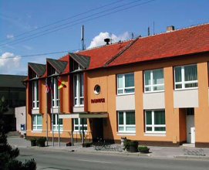
Podivín town | Velké Bílovice – town hall

Individual seats create their own local market on the basic level – their own shops, schools and other equipment. From it follows that small towns in this territory have hardly any central function, because they can offer the same level of services as a majority of their neighbours. The way is looked for in specialisation of individual small towns and villages.

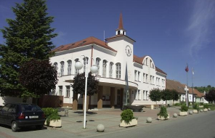 | 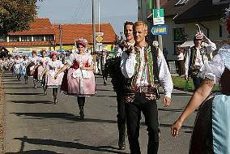
Velké Pavlovice – town hall | Velké Pavlovice – Harvest celebrations

Bořetice – Village of the Year 2005

Population about 1,300, 510 houses, 912 ha, 208 m above the sea level, first mentioned 1222.
The village has been successful in the competition called “Village of the year” in 2005, which is held every year by the Association for restoration of rural areas, Ministry for rural development and the Association of towns and villages in Czech Republic. The aim of the competition is to evaluate activity of the village, both inhabitants and representatives, in enhancing their home and in local tradition, social life and village and its landscape development and point out the importance of rural areas. The most successful from the entered villages wins the golden ribbon and the title “Village of the year”.

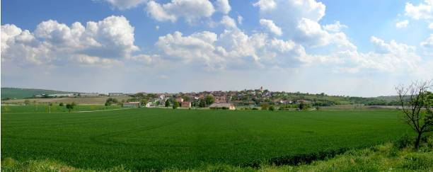

Wineyards 169 ha, wine making first mentioned in 1361, 260 wine cellars
In the middle ages the community suffered from raids as it was located close to the Moravian/Hungarian and Moravian/Austrian borders. It was plundered and burnt down many times. St. Ann church, renewed in the baroque style after the Hungarian attack in 1680

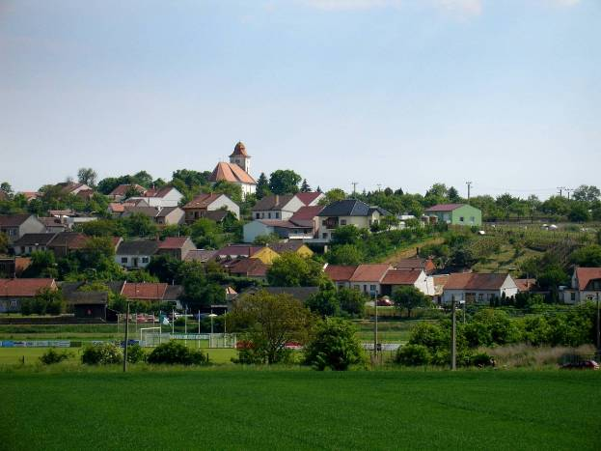

Agricultural co-operative Bořetice, specialized in poultry keeping; growing of soya, rape, sunflower, wheat, corn
The largest firm: LOMAX Ltd., garage doors, retail network in Czechia, Slovakia, Austria, productive branches in Czechia and abroad, found 1992, situated in the industrial zone Bořetice

Free Federal Republic of Kraví hora (Cow hill)

The Free Federal Republic of Kraví hora is situated in the territory of winegroving area of the village of Bořetice. This area was separated from the village by a lake until the year 1835, and wine growers had to use boats across the lake to reach their vineyards and wine cellars.
The Republic was constituted at November 12, 2000 when the president of the Republic was elected. He is responsible for all activities connected with wine/growing and wine dealing, including publicity. On April 18, 2001, a sub-committee for heraldry of the Czech Parliament granted to the Republic the right to use the coat of arms and flag.
Wine industry has had a long tradition in the village. After the Thirty Year´s War (17th century), most vineyards suffered from damage, and they were only slowly restored. The appearance of phylloxera in 1909 was another hard blow for wine industry. A considerable decline of vineyard area followed after agricultural co/operative farms were established and the same policy continued after several co/operative farms in the region merged. Finally, after 1989, the co-operative farm Velké Pavlovice has taken no interest in wine industry and therefore only medium-sized and smaller vineyards on a private basis save the situation today. According to the wine industry law, the village is a part of Velké Pavlovice wine region.

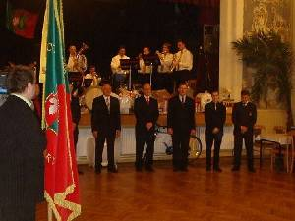 | 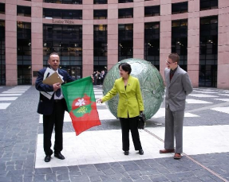
The government of the Republic | Honorary consul of the Republic in Strasbourg

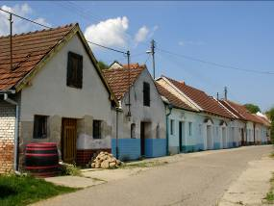 | 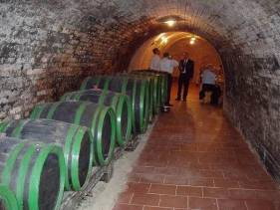
Vine cellars in Kraví Hora | Vine cellar interior

